Create a LAN

In this project we used Cisco’s packet tracer to create a LAN with the relevant details within the Addressing and Connections Table, using both DHCP and Static IPv4 addresses. The goal was to connect each end device to the Switch using the correct ports and wiring.

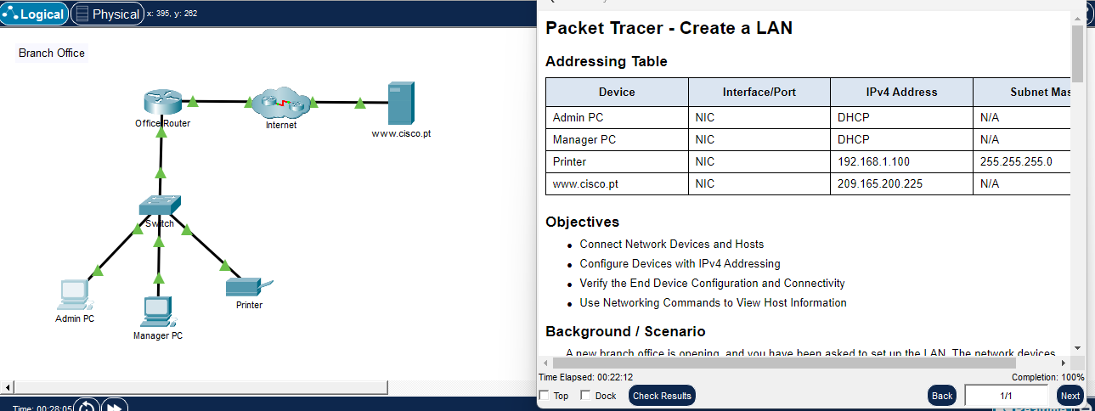
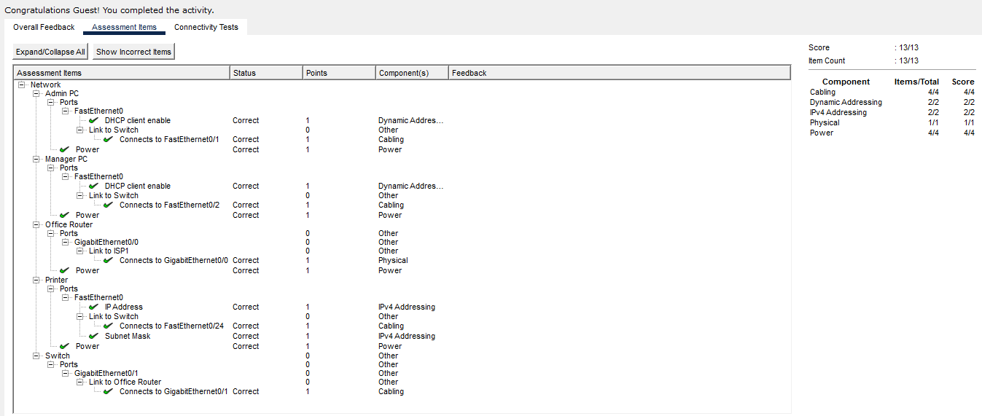
First, I connected the devices appropriately, then enabled DHCP on both the router and PCs. The printer was to be set up statically to IP 192.168.1.100. Then to confirm connectivity of the devices I used the command line per device to check IP setup with ipconfig. This allowed me to use ping to each IP per end device to check for a packet response. I then entered the IP address of the server into the Admin PC to ensure I was receiving a response, in which I repeated using the server URL in-case of DNS issues. I also used tracert with the server URL to observe packet routes from the source PC through the routers.

